Assignment – 1

Architectural Discussion Responses – National Real-Time Payments System

Architecture Overview
National Real-Time Payments System to enable instant digital payments between citizens, businesses, and financial institutions. The platform aims to become the primary backbone for all peer-to-peer (P2P) and peer-to-merchant (P2M) transactions, replacing cash and traditional delayed banking transfers.
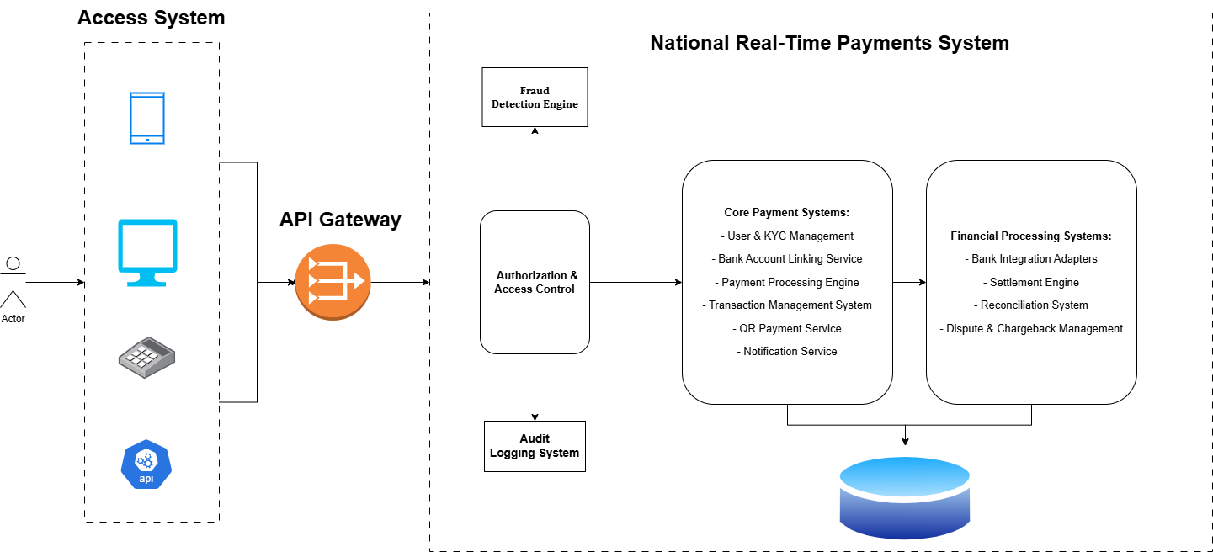
Fig 1 Overall Architecture

- What are the various systems and subsystems required to deliver this functionality?
To deliver A national-scale real-time payments, the platform must be composed of multiple distributed systems organized as follows.
- Platform Access Systems:
  - Mobile Applications (iOS/Android)
  - Web Applications
  - Merchant POS Systems
  - Third-party API integrations

- Security Access & Control Systems:
  - API Gateway
  - Identity & Authentication Service
  - Authorization & Access Control
  - Rate Limiting & Load Balancing
- Core Payment Systems:
  - User & KYC Management
  - Bank Account Linking Service
  - Payment Processing Engine
  - Transaction Management System
  - QR Payment Service
  - Notification Service
- Financial Processing Systems:
  - Bank Integration Adapters
  - Settlement Engine
  - Reconciliation System
  - Dispute & Chargeback Management
- Risk & Compliance Systems:
  - Fraud Detection Engine
  - Risk Scoring Service
  - Audit Logging System
  - Regulatory Reporting Module
- Data & Infrastructure Systems:
  - Transaction Databases
  - Distributed Cache
  - Event Streaming Platform
  - Monitoring & Observability Tools
  - Backup & Disaster Recovery

- What kind of information is exchanged between systems?
The system exchanges high-frequency financial and operational data requiring strong consistency and low latency.
Authentication Tokens: very high frequency, milliseconds latency, strong consistency.
Payment Requests: continuous flow, <2 seconds processing, very high volume, strong consistency.
Fraud Signals: real-time exchange, milliseconds speed, near real-time consistency.
Bank Settlement Data: periodic exchange, seconds to minutes latency, strong consistency.
Notifications: event-driven, seconds latency, eventual consistency.
Audit Logs: continuous asynchronous logging, immutable consistency model.Critical financial transactions require strong consistency, while logs and notifications can follow eventual consistency.
- What are the major potential failure points in this system?
The followings are major potential failure can be possible in the system
Technical Failures:
  - Database overload or crash
  - Service instance failures
  - Network latency spikes
  - Message queue congestion
  - Data center outages
Integration Failures:
  - Bank API downtime
  - Version incompatibility
  - Settlement synchronization failures
  - Third-party API throttling
External Dependency Failures:
  - Banking network disruptions
  - Telecom network issues
  - Cloud provider outages
  - Regulatory service downtime
- What mitigation strategies would you design to prevent or reduce failures?
The following are the recommended mitigation strategies:
- Resilience Design:
  - Multi-region deployment for support Cross Country payment system
  - Active-active redundancy for failure recovery
  - Auto-scaling infrastructure for load management
- Fault Isolation:
  - Circuit breakers
  - Retry mechanisms with exponential backoff
  - Bulkhead isolation pattern
- Data Protection:
  - Transaction idempotency
  - Event sourcing
  - Distributed replication
- Operational Controls:
  - Real-time monitoring
  - Automated failover
  - Health checks
- What contingency plans are required when failures do occur?

- Operational Measures:
    - Manual reconciliation workflows
    - Deferred settlement processing
    - Queue-based retry execution

- User Communication:
    - Real-time status notifications
    - Transaction pending indicators
    - Transparent failure messaging

- Financial Safety:
    - Transaction journaling
    - Audit-based recovery
    - Compensation transactions
- How should the system behave differently under:
Normal Daily Load:
  - Synchronous transaction processing
  - Real-time fraud checks
  - Standard scaling levels
  - Immediate settlements

Peak National Events:
  - Auto horizontal scaling
  - Priority transaction queues
  - Graceful degradation of non-critical services
  - Increased caching usage
  - Asynchronous processing for reports and analytics
7) What architectural trade-offs would you make between:
Consistency vs Availability:
  - Strong consistency for payments
  - High availability for non-critical services
Cost vs Reliability:
  - Higher cost accepted for payment core
  - Cost optimization for analytics workloads

Real-time vs Eventual Processing:
  - Real-time authorization and confirmation
  - Eventual consistency for reporting and notifications

Security Depth vs User Experience:
  - Adaptive authentication
  - Strong security for high-risk transactions
  - Minimal friction for trusted users

8) Refer to similar global implementations and highlight the USPs and additional features that your solution recommends. Highlight the impact and ROI of these additions.
Several countries have successfully implemented real-time payment infrastructures, such as India’s UPI, Brazil’s PIX, and the UK’s Faster Payments system. These platforms demonstrate the importance of interoperability, simplicity, and scalability.
Recommended USPs:
  - AI-based real-time fraud prediction
  - Offline payment capability
  - Smart routing across banks
  - Cross-border instant payments readiness
  - Open API developer ecosystem
Impact & ROI:
  - Increased digital transaction adoption
  - Reduced cash handling costs
  - Faster merchant settlements
  - Improved financial inclusion
  - International payment revenue opportunities

